

**2021 SUBWAY Junior Invitational Prize Breakdown**

**KenWo Golf Club**

**21st ANNUAL SUBWAY JUNIOR INVITATIONAL CHAMPIONSHIP**

**Overall Champions**

**Boys Champion – Ryan Frizzle (74)**

**Girls Champion – Emma Rushton (79)**

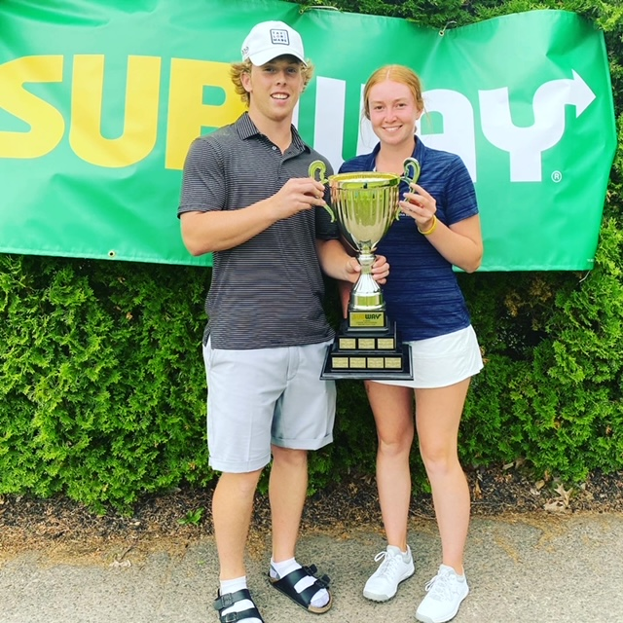

**Junior Girls Division**

U17 Girls Champion Ava MacDonald (97)

U15 Girls Champion Avery Cohen (85)

1st Gross Kate Pemberton (87)

1st Net Emmerson MacDonald (Net 71)

2nd Gross Tatum Lohnes (106)

U13 Girls Champion Claira Frizzel (86)

1st Gross Daniella Kim (92)

1st Net Zara Kenley (Net 80)

U11 Girls Champion Lila Bishop (73)

1st Gross Priya Dixon (74)

2nd Gross Charley Levy (88)

**Junior Boys Division**

U19 U19 Champion Ben Levy (76)

1nd Low Gross Harrison Seaman (77)

U19 Boys 1st Low Net Owen Sypher (72)

U17 Boys U17 Champion Braden Hammond-Bridges (77)

1nd Low Gross Justin Conrad (80)

2rd Low Gross Colby Bent (81)

3rd Low Gross Carson Logie (81)

U17 Boys 1st Low Net Blake Fish (71)

2nd Low Net Jack Foerster (74)

3rd Low Net Evan Allain (75)

U15 Boys U15 Champion Ben Brown (78)

1nd Low Gross AJ Campbell (79)

2rd Low Gross Samuel Dixon (83)

3rd Low Gross Wesley Roy (84)

4th low Gross Grady Cohen (84)

5th low Gross Jesse Sinclair (87)

6th low Gross Liam Marshall (88)

1st Low Net Tyler Schmeisser (71)

2nd Low Net Vincent Armstrong (73)

3rd Low Net Xavier Leblanc (74)

4th low Net Aiden Fry (77)

5th low Net Austin Mackay (77)

6th low Net Nicolas Doucet (80)

U13 Boys Champion Jacob Seaman (72)

1nd Low Gross Luke McDougall (73)

2rd Low Gross Nathan MacDonald (86)

U13 Boys 1st Low Net Bentley Mackay (net 75)

2nd Low Net Elliott Bishop (net 76)

U11 Boys Champion Borden Nicholson (60)

1st Low Gross Josh Nickerson (62)

2nd Low gross Yousef Rafih (62)

3rd Low gross Carrick Frizzel (63)

4th Low gross Andrew MacDonald (64)

5th Low gross Lee Wilson (65)

6th Low gross Lachlan Campbell (67)

7th Low Gross Lucas Lunn (67)