2020 SUBWAY Junior Invitational – Results
Ken-Wo Golf Club

21st ANNUAL SUBWAY JUNIOR INVITATIONAL CHAMPIONSHIP

Overall Champions
Boys Champion – Logan Forward, Oakfield 73
Girls Champion – Haley Baker, Ashburn 76

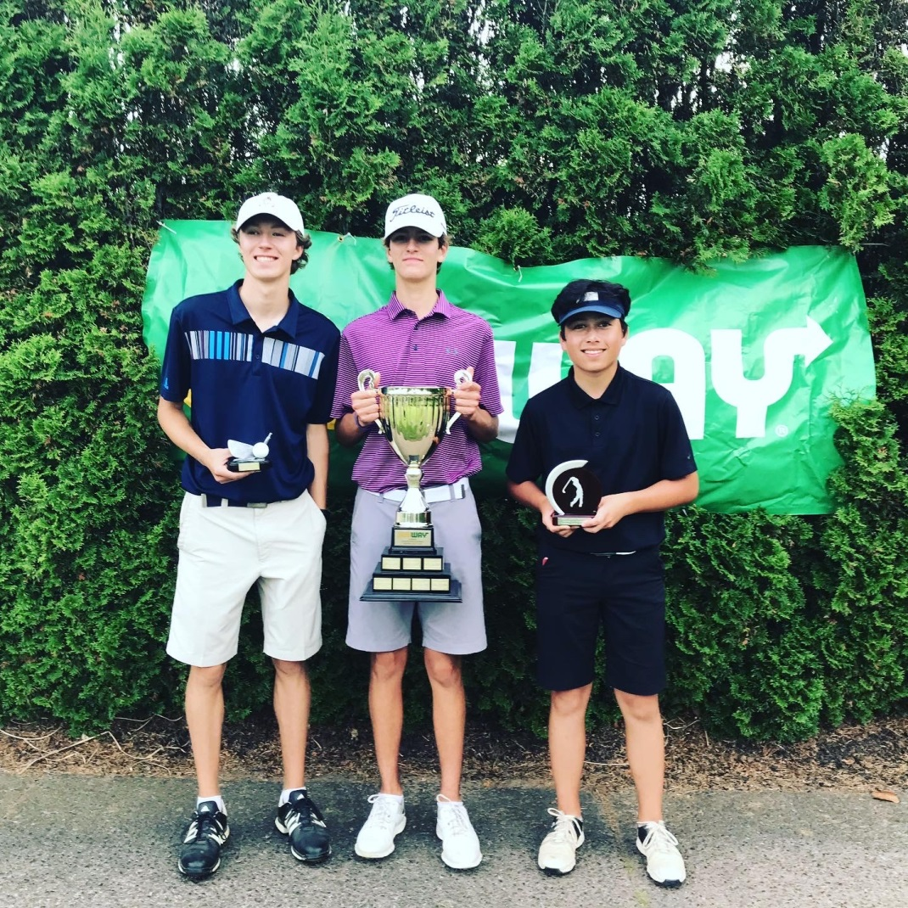
Finn Kimball, Logan Forward, Nathan Li
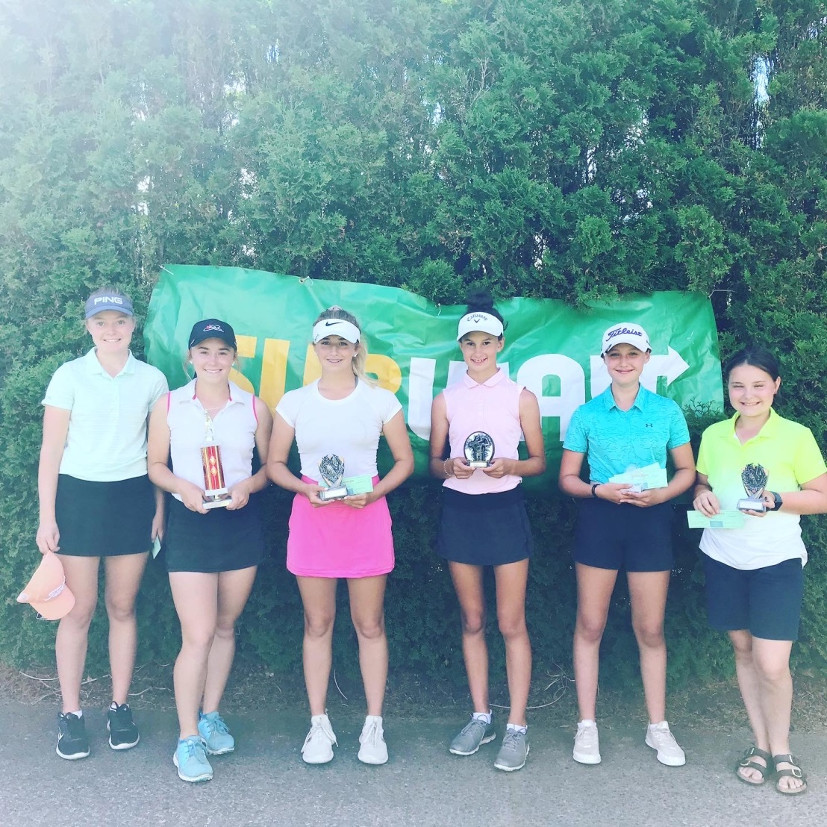
Lauren Rushton, Haley Baker, Abbey Baker, Olivia Seaman, Avery Cohen, Claira Frizzell

Junior Girls Divisions

Junior Junior Champion Lauren Rushton, Ken-Wo 82

Juvenile Juvenile Champion Abbey Baker, Ashburn 77
1st Gross Danielle Cumby, Ken-Wo 77
1st Net Emma Rushton, Ken-Wo 78net

Bantam Bantam Champion Olivia Seaman, Ken-Wo 88
1st Gross Annika Parkash, Ashburn 91
1st Net Emily Trider, Avon Valley 92net

PeeWee PeeWee Champion Avery Cohen, Abercrombie 91
1st Gross Kate Pemberton, Avon Valley 97
1st Net Bria Cowan, Chester 75net
2nd Gross Isobel MacDonald, Ken-Wo 110
2nd Net Cayden Cowan, Chester 78net

Novice Novice Champion Claira Frizzell, Hartlen Point 68
1st Gross Lila Bishop, Ken-Wo 82
2nd Gross Chloe Bishop, Ken-Wo 83

Junior Boys Divisions

Junior Junior Champion Finn Kimball, Osprey Ridge 76
1nd Low Gross Jacques Forgeron, Grandview 79
2rd Low Gross Gavin Keating, Brunello 81
3rd Low Gross Matthew Schnurr, Oakfield 82

Junior 1st Low Net Liam Keats, Ken-Wo 58net
2nd Low Net Ian Johnston, Grandview 73net
3rd Low Net Jeff Comeau, Grandview 74net

Juvenile Juvenile Champion Nathan Li, Ken-Wo 75
1nd Low Gross Harrison Seaman, Ken-Wo 75
2rd Low Gross Zach Woods, Grandview 76
3rd Low Gross Quinn Hayden, Truro 79

Juvenile 1st Low Net Jack Shaw, Ken-Wo 71net
2nd Low Net Jack Pemberton, Avon Valley 73net
3rd Low Net Benjamin Levy, Avon Valley 74net

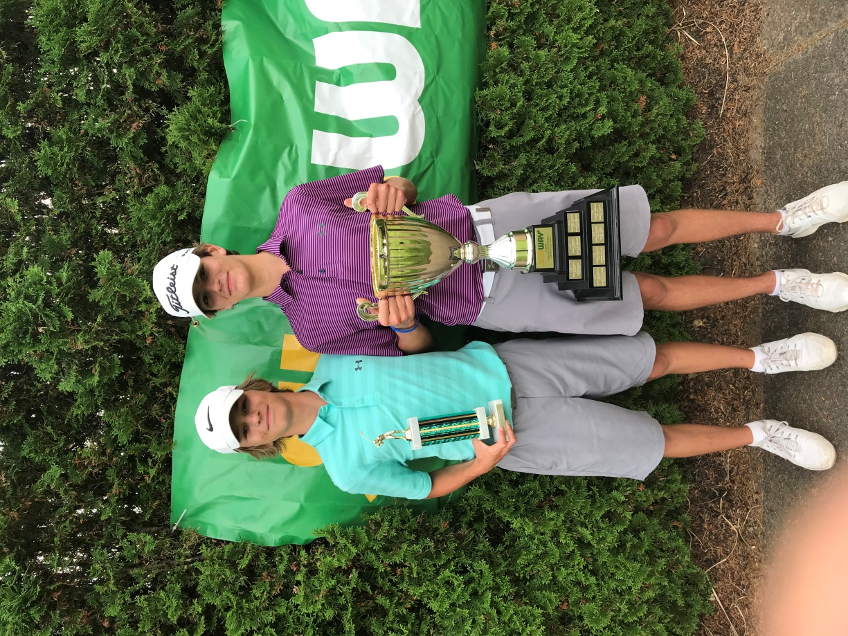
Hudson Forward and Logan Forward

Bantam Bantam Champion Hudson Forward, Oakfield 78
1nd Low Gross Matthew Brooks, Oakfield 81
2rd Low Gross Will Denny, Lost Creek 83
3rd Low Gross Jack Foerster, Brunello 91
4th low Gross Max Baldwin, Glen Arbor 91

Bantam 1st Low Net Jacob White, Ken-Wo 71net
2nd Low Net Brennan MacKinnon, Fox H. 72net
3rd Low Net Decklin Palmer, Ken-Wo 72net
4th Low Net Ben Robson, Penn Hills 74net
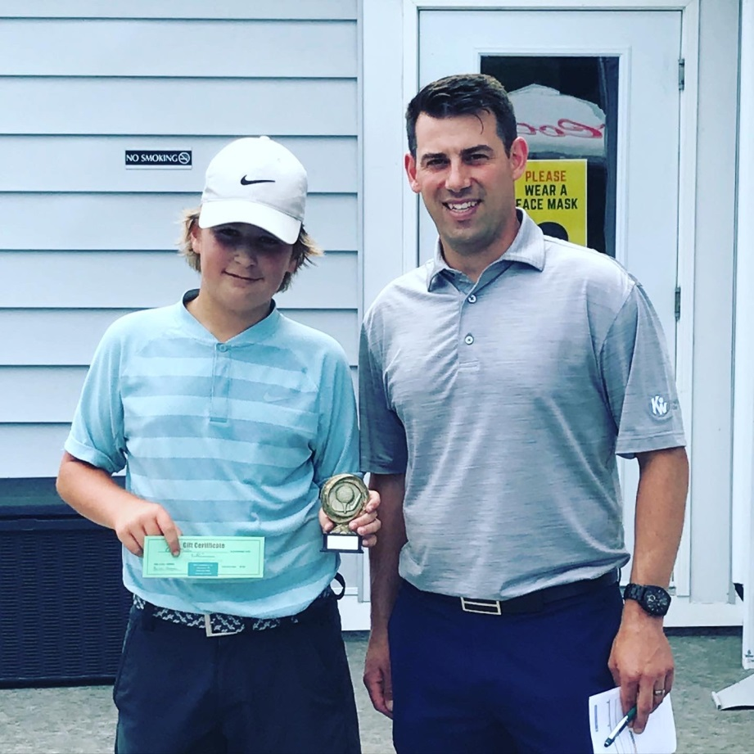
Elliott Mullen and Derek MacKinnon

Peewee PeeWee Champion Elliott Mullen, Truro 74
1nd Low Gross Blake Wilson, Oakfield 76
2rd Low Gross Kooper MacKay, Ken-Wo 80
3rd Low Gross Rylan Sutherland, Brookfield 81

Peewee 1st Low Net Sam Dixon, River Hills 68 net
2nd Low Net Liam Marshall, Ken-Wo 75net
3rd Low Net Grady Cohen, Aber 79net

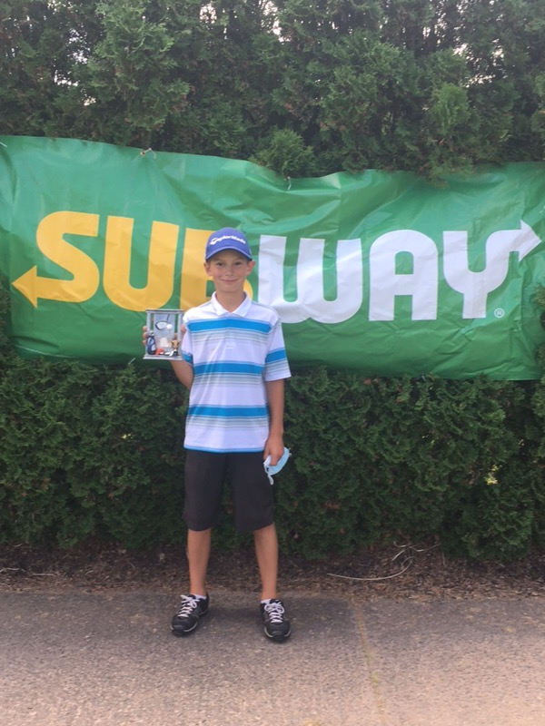
Jacob Seaman

Novice Novice Champion Jacob Seaman, Ken-Wo 51
1st Low Gross Nathan MacDonald, Oakfield 53
2nd Low gross Luke Nickerson, Ken-Wo 61
3rd Low gross Alex Wenckowski, Eden 65
4th Low gross Hunter Hood, Avon Valley 65

1st Low Net William Starkey, NSPP 47net
2nd Low Net Elliott Bishop, Ken-Wo 47net
3rd Low Net Nolan Brown, Antigonish 56net
4th Low Net Paxton Levy, Ken-Wo 59net

*Novice played 13 holes

